SECTION 1: Getting Started

Query Editor

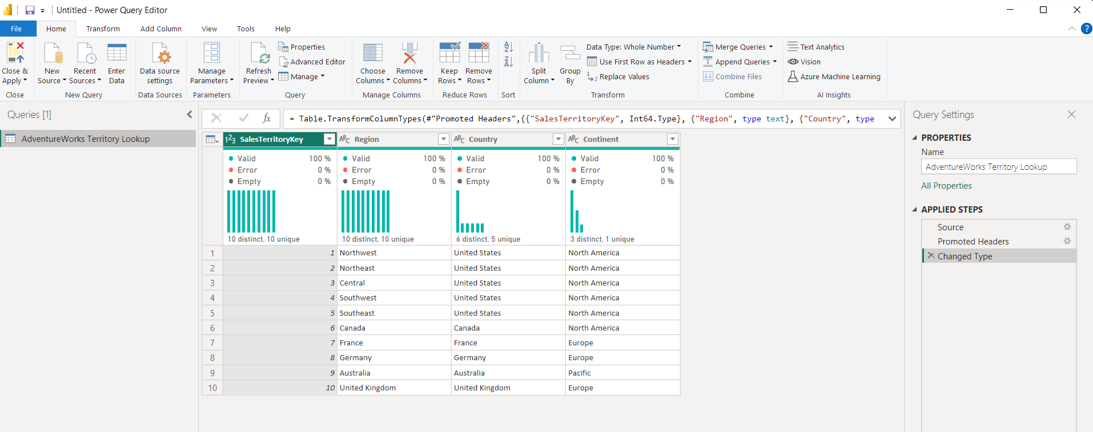

POWER QUERY EDITOR – M Language

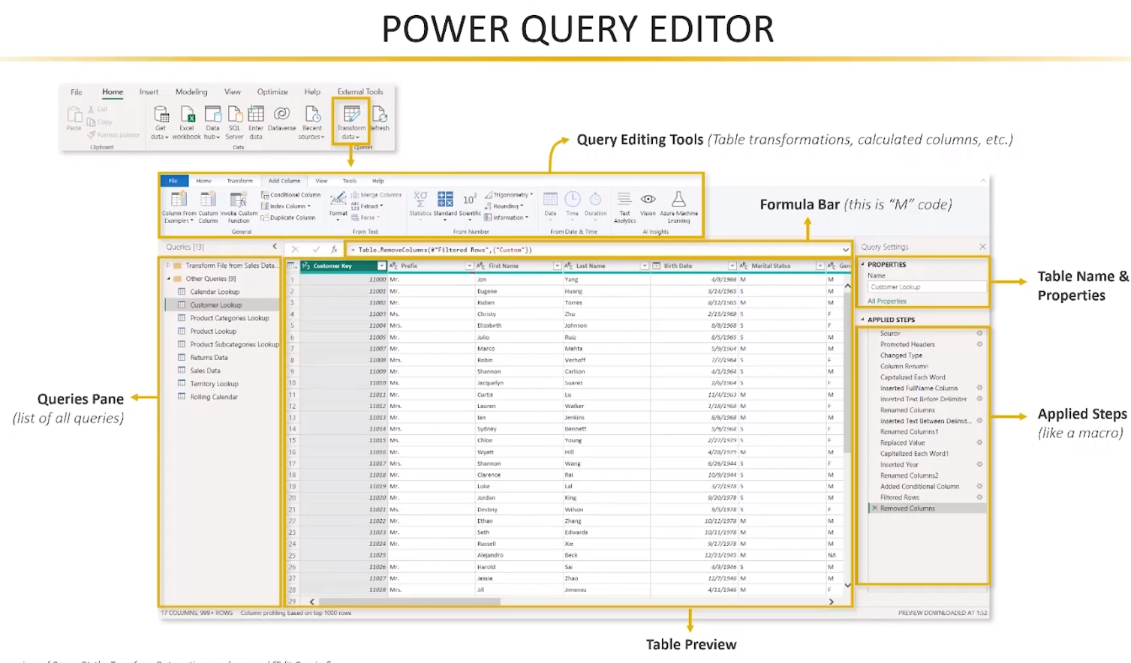

Primary Tabs

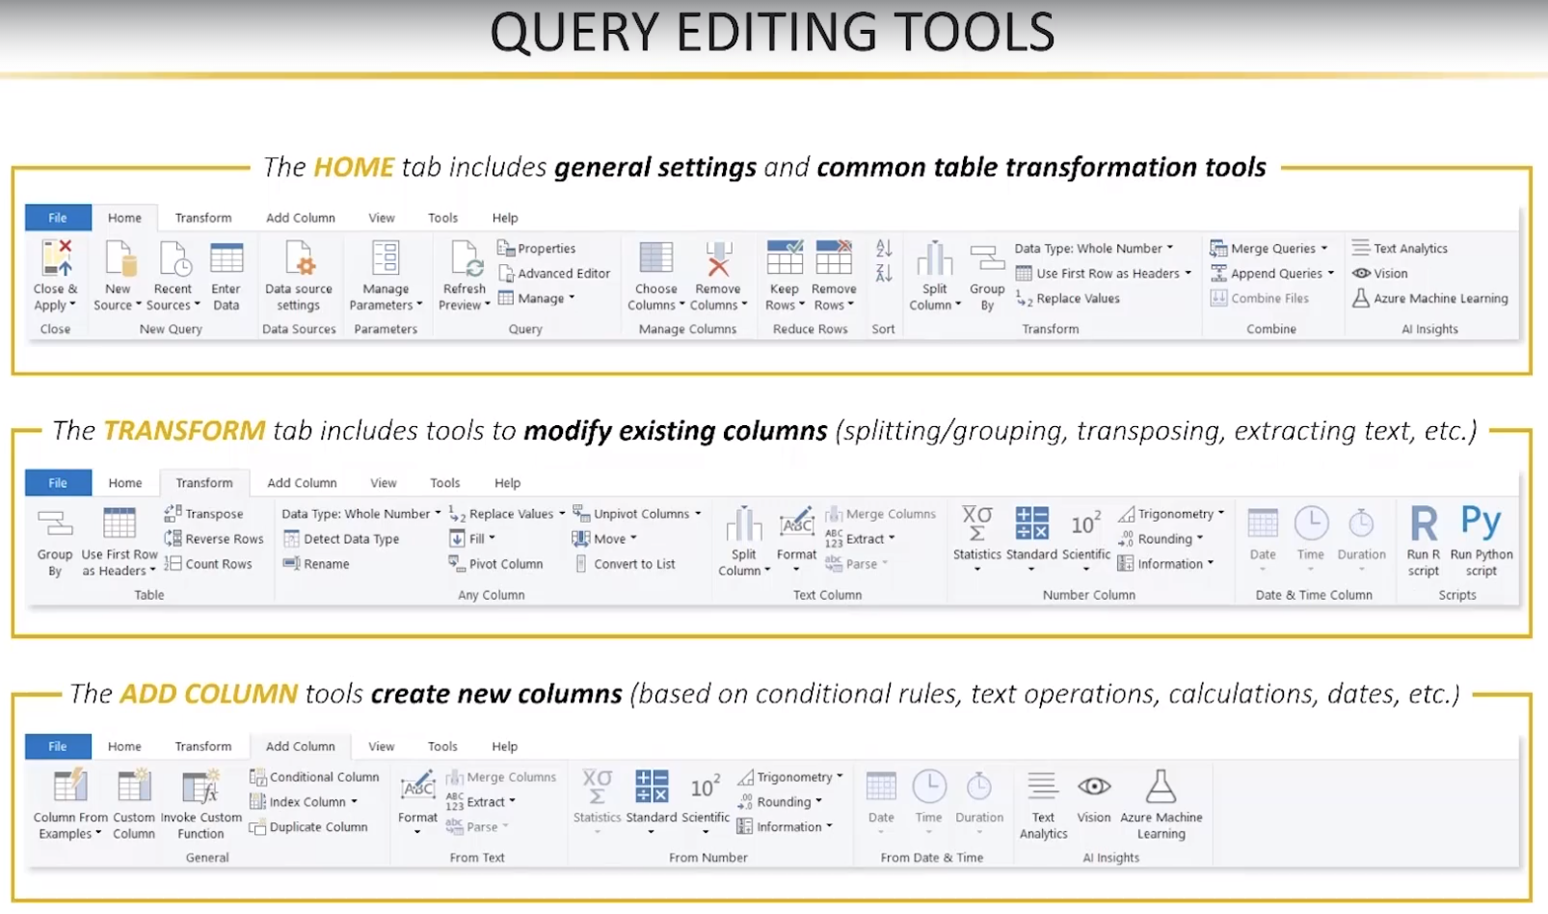

BASIC TABLE TRANSFORMATIONS

Two important steps:

1. rename the file
2. checking if the columns are correct define/organized (data type)

You can rename the steps to be more readable.

Use the first row as headers.

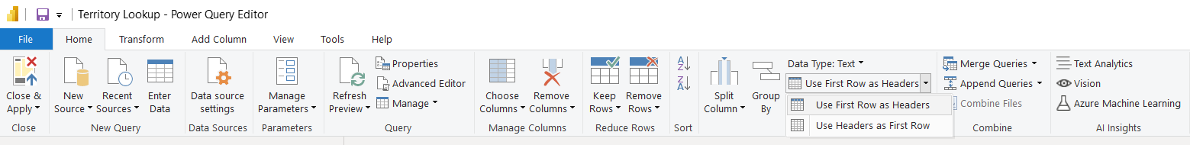

Apply changes – load the data in the Power BI Model

Data Model

STORAGE & CONNECTION MODES

CONNECTING TO A DATABASE

Connect to a MySQL database.

Click Connect